1. You can access your inbox two ways.
2. Go to the cloud in the corner and go to your inbox

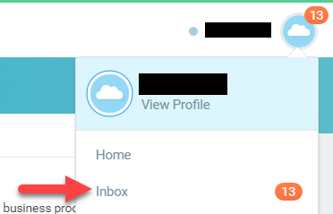

1. Go to the worklet on your home page



1. Once in your inbox on the actions tab, click on the rt arrow ‘My Delegations’

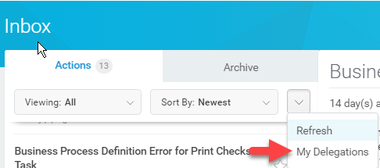

1. You will see 5 tabs across the top that will break down your delegations



1. If you want to manage your delegations then you click on 
2. Update your Begin Date/End Date
3. On the delegate task you will have the option to enter either peers/superiors

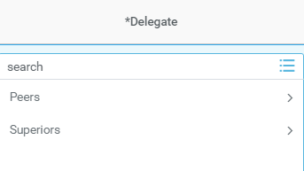

1. ‘Start On My Behalf’ is based off the business process type that’s feeding into your inbox

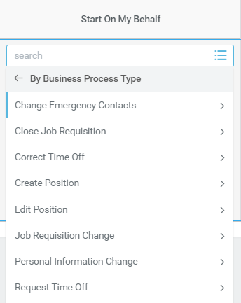

1. ‘Do Inbox Tasks On My Behalf’

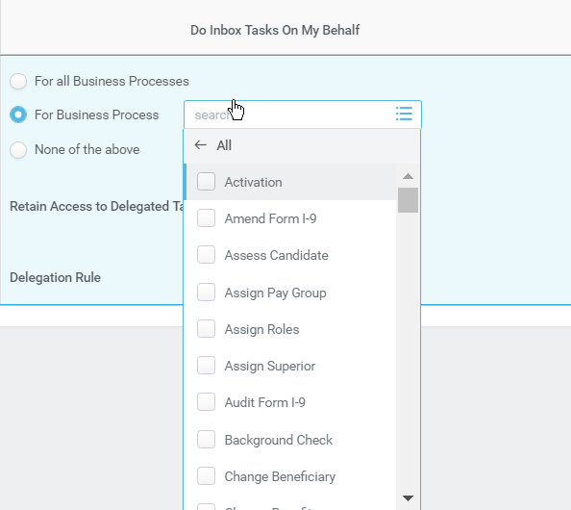

NOTE\*\*\*\*If you select ‘Retain Access to Delegated Tasks In Inbox’ on certain BP’s you will still retain access while you are out in case you want to check in to make sure they are being completed.

